Assignment 4 : create war on Jenkins master put war on s3 . In jenkins slave get object war and deploy it

* Shweta Raut

Configure Jenkins master .

Attach IAM role to it with s3-full-access

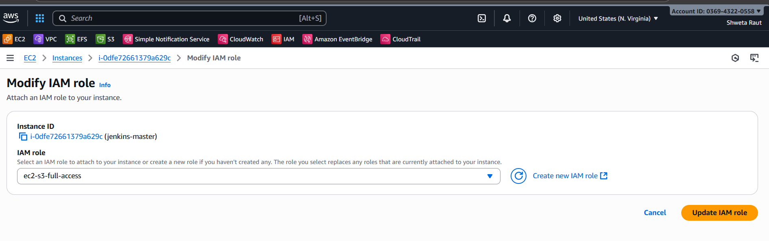

Create one freestyle job run it on Jenkins master

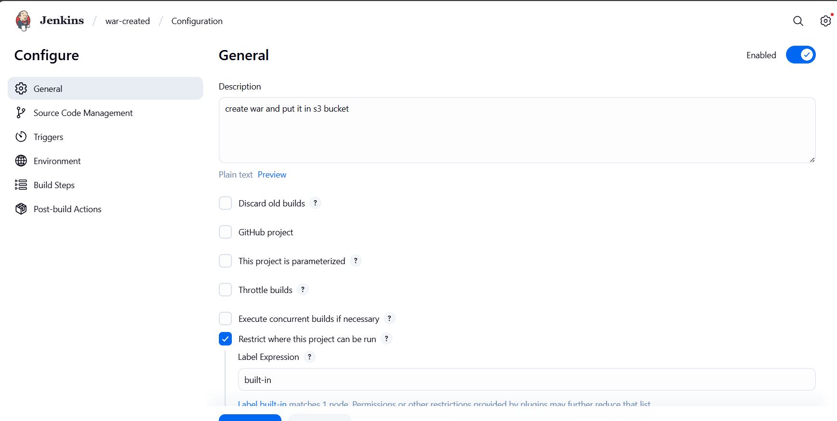

Integrate git repo

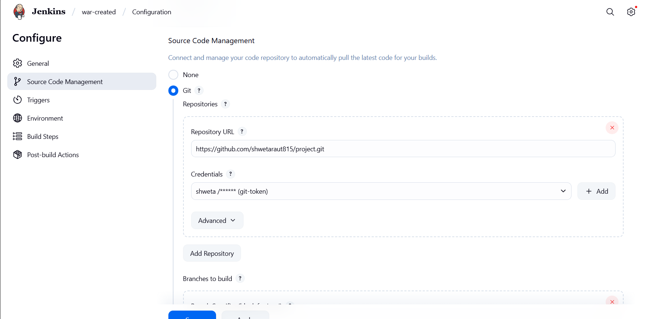

Integrate maven to build the war from the source code present in the git repo

Add build step to create a s3 bucket

Copy the content from workspace to s3 bucket

aws s3 mb s3://war-application-7657

aws s3 cp /root/.jenkins/workspace/war-created/target/LoginWebApp.war s3://war-application-7657

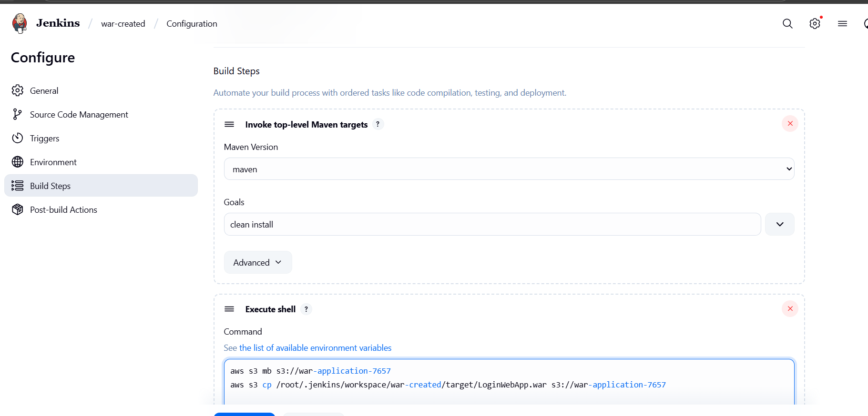create a Jenkins slave

attach IAM role with s3-full-access

configure Jenkins-slave

# install maven, java-17

# install tomcat server, start the tomcat server script

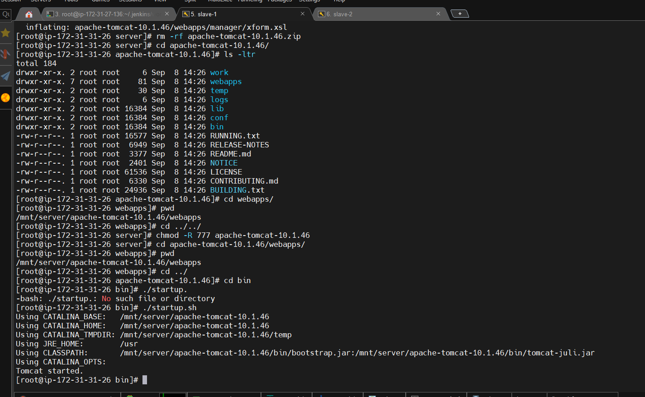

Create freestyle job which run on slave

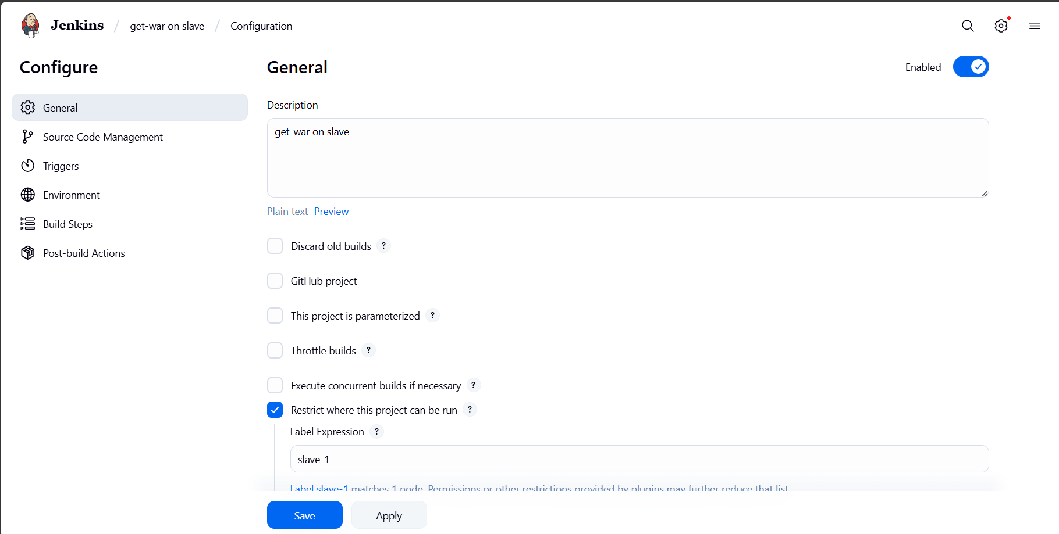

Get object from s3 bucket and copy it to webapps folder of tomcat-home

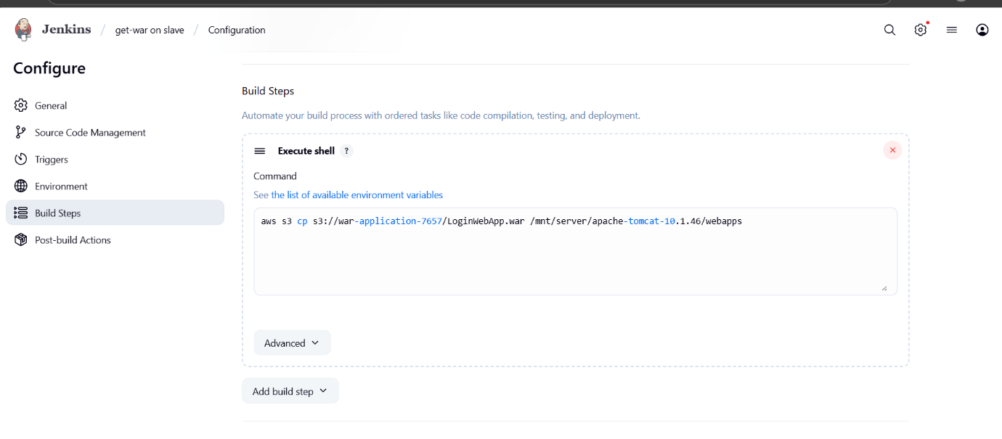

Build it

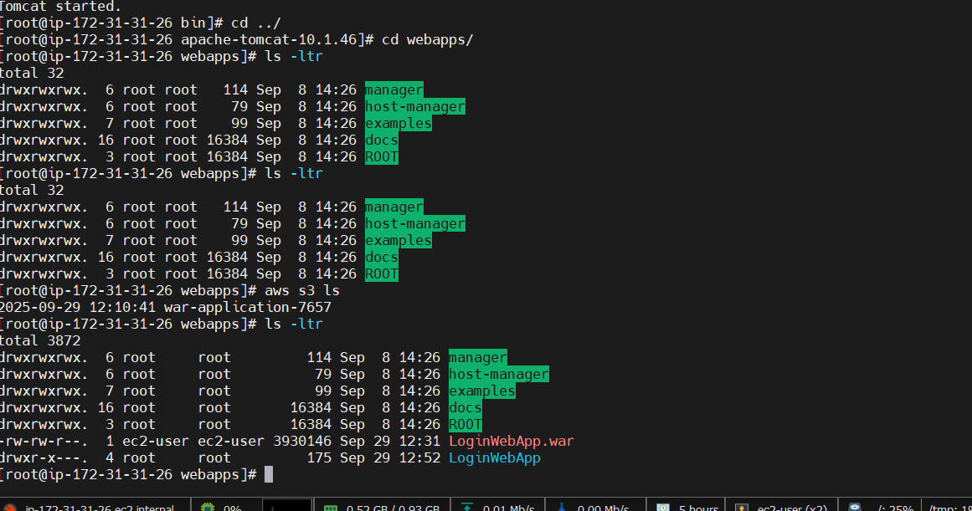

Access webapplication on browser from Jenkins slave

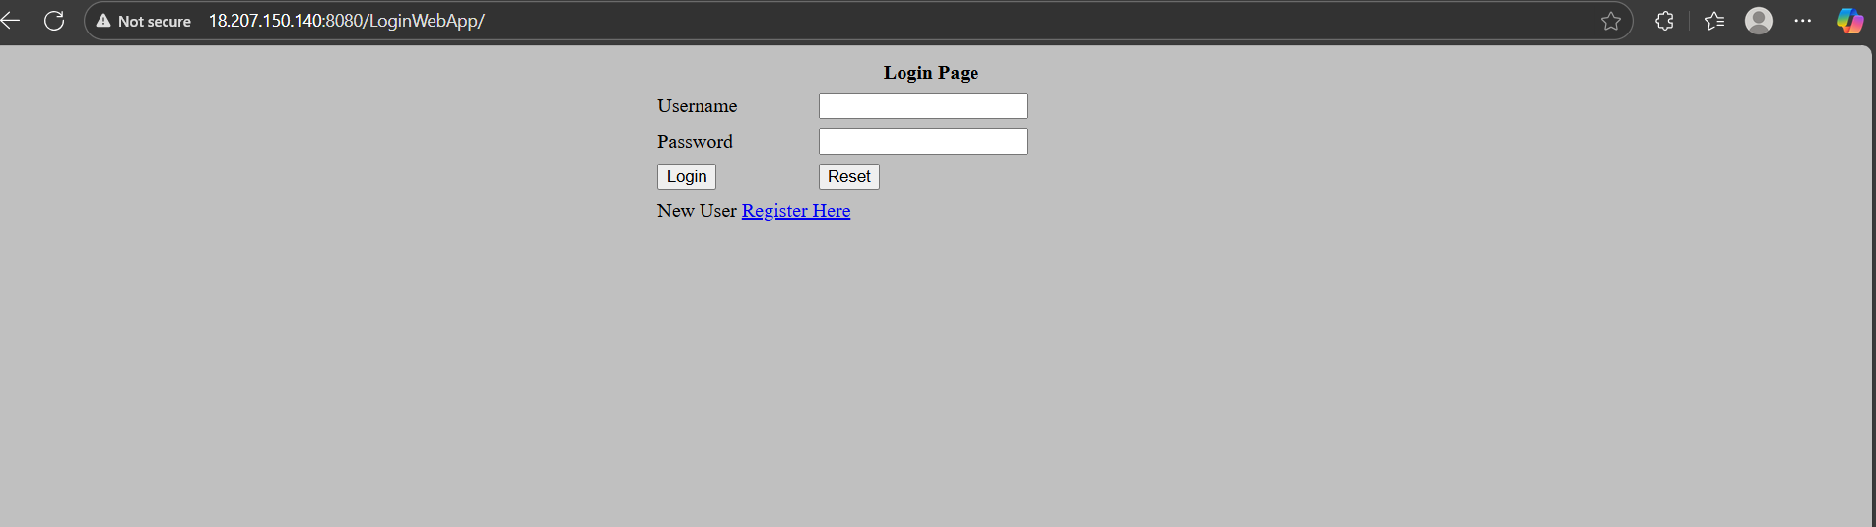  
 DONE!!!!!!!